Edwalton, Gamston & District u3a (EGDu3a)
Newsletter May 2023
Our Motto is ‘Live, Laugh and Learn’ – but most of all LAUGH!

“You know you’re getting old when you stoop to tie your shoelaces and wonder what else you can do while you’re down there” (George Burns)

ON GIVING UP HIS EARLY CAREER (BOXING) - "I ruined my hands in the ring. The referee kept stepping on them." (Bob Hope)

Thurs 11 May, 1.30 pm – Monthly Meeting at Edwalton Church Hall, NG12 4AP
Martin Perry will talk about ‘The Magic of the Guitar’

Martin, a retired Deputy Head of a Comprehensive School, not only gives talks on the guitar but also writes walking books. This talk begins in the 1950s and covers the dramatic effect that the electric guitar had on popular music from the 1960s onward. He will demonstrate various sounds and playing techniques and, if the mood is right, we might enjoy a bit of a sing-along.

1. Please bring along the correct entrance fee (£1 per member or visitor).
2. Tea/coffee will be available but please bring along your own mug or cup.
3. The Church Hall is located at 1 Vicarage Green, Edwalton and can be accessed via Wellin Lane or Edwald Road.
4. COVID-19 is still a risk. Please do not attend if you have any COVID-19 symptoms.

Planned Speakers for 2023 (Jo Cutts)

Thurs 8 June: Vince Eager will tell us ‘You are Never too old to Rock and Roll’
Thurs 13 July: Martin Lloyd will talk about ‘Passports, Assassins, Traitors and Spies’

A Fab Trip to Liverpool!

Our Outings Team, in a pioneering move, organised a residential trip to Liverpool which ran 17-19 April. The trip was a great success. A total of 23 of our members enjoyed a variety of activities in de ‘pool. It was an event that is certainly worthy of repetition. Those attending enjoyed the opportunity to spend more time together in a very interesting city. Thanks go to Prue Brandt and Janet Johnson who did a splendid job of organising everything. We look forward to hearing plans for the next residential visit.

Come and Join our Executive Committee! (Susan Bryant)

The Executive Committee effectively manages and organises our u3a and its members take on different roles. Committee members can serve only for a fixed period of time and, at our AGM in September, some committee members must step down. In particular, we will need to replace the posts of Speaker Seeker, Groups Coordinator, Membership Secretary, Newsletter Editor and Website Manager. The responsibilities are not huge and help is available from existing Committee members. If you are interested in a particular position, you can learn more by contacting the Chair, Business Secretary or current post holder. Please volunteer if you can!

EGDu3A Website (John Todd)
Our website (https://edgamu3a.weebly.com) provides information about the monthly meetings, interest groups, how to join, etc. The website is now managed by John Todd who adds Newsletter updates to the site after redacting phone numbers and emails.
Notes from Groups Coordinator (John Todd)
There has been a change of leadership of the Sunday Singles Group from Cherry Brandon to Barry Coulby and Marie Smith. Cherry established the group four years ago and we say a big ‘Thank you’ to Cherry for her contribution and enthusiasm.

Any member wishing to join a group can simply contact the group’s leader or myself. You can also tell me if you would like to start a new group. Contact me either at a monthly meeting por through the contact page on the website.

EGDu3a Current Interest Groups

If you are not a member of this u3a but would like more information please contact the Groups Coordinator through the contacts page of this website.

Art Appreciation (Roy Townsend): Usually, we meet on the morning of the 3rd Wednesday of the month with venues rotating through members’ homes. We meet next in Roy’s home at 10.30 am on Wed 10 May (notice date brought forward a week by members’ agreement) for ‘Propaganda’ (Sue Law) and ‘Beauty’ (Roy). New members are welcome.

Board Games Group (Geoff Challinger): This group usually meets at 2.00 pm on the 1st Monday of each month at 62 Melton Gardens. However, with an imminent attack of multiple May bank holidays, we're planning on changing the normal 1st Monday to the 3rd Monday in May. So, we will meet next on Mon 15 May. If you are interested in joining us, please get in touch.
Book Group (Roy Townsend): Meets on the 2nd Tuesday of the month at 2.30 pm in a member’s home. We meet next on Tues 9 May at a venue to be confirmed (possibly Pat Brunger’s house) for ‘The Midnight Library’ by Matt Haig. New members are welcome.

Bridge Group (Wendy Danzey): We meet at Josephine Cutts’ house each Tuesday at 2.15 pm, so next on Tues 2,9,16 + 23 May. We have 10 members who play and usually have 2 tables each session. We would be pleased to welcome anyone interested in joining us..

Chatterbox/Coffee Shop Group (Chris Shaw/Pauline Barrett): Meets on the last Thursday of the month at 10.30 am in The Poppy & Pint, Lady Bay for tea/coffee and gossip/chat.
Church Visiting Group (Mike Groves): Roughly once a month, we visit churches of architectural interest followed by lunch together. Our next visit will be on Wed 3 May to the modern Catholic Church of Our Lady of Grace, Cotgrave, followed by a tour of All Saints Parish Church. The latter is a Grade 1 listed building dedicated in 1246 and beautifully restored following a catastrophic fire in 1996. We can park at our Lady’s for a tour at 10.00 am and then a walk around All Saints at 11.30 am. We will lunch at the nearby Manvers Arms between the two churches. Please note that we are also arranging a visit to the civic church of Nottingham, St Mary’s in the Lace Market, on Tues 20 June at 11.00 am. Further information and sign-up lists will be available at our next Open Meeting on Thurs 11 May.
Craft Group (Sheila Golledge): Meets on the 1st Monday of the month at 10.00 am in The Holy Spirit Social Centre, Victoria Rd, West Bridgford. Cost £3 for hire of hall and a donation of 50p towards refreshments. We are due to meet next on Mon 1 May, but this is a Bank Holiday, so the next meeting will be on Mon 5 June. New members are welcome.
.
Craft Project Group (Chris Sutherland): We are affiliated to the Craft Group but have our own agenda. We meet at 10.00 am on the 3rd Monday of the month at the home of a group member. The next meeting is on Mon 15 May.

Cycling Group (Isabel Martindale): Rides are arranged according to weather and availability but usually occur on the 1st and 4th Monday or Friday. We would welcome other members.

French (Eileen Loftus): We are a mix of learners and competent speakers seeking to improve our reading, writing and speaking skills. We now meet twice per month. Our main meeting is on the 3rd Wednesday of the month (Wed 17 May) at 10.30 am in The Poppy and Pint in Lady Bay with an ad hoc meeting on the 1st Wednesday for those who cannot commit to regular attendance twice a month.

Gardening (Fiona Steele): We meet on the 1st Thursday of the month, in the afternoon, at members’ homes or other locations. Our next meeting will be at 2.00 pm on Thurs 4 May to visit Edwalton Church Garden and a private garden belonging to a u3a member, also in Edwalton. For further details please contact Carol Shuttleworth and, for information about the group, contact Fiona.

History (Kuo Hsiang Choong): We meet at 10.30 am in the Willow Tree pub on the 2nd Wednesday of the month to study various aspects of History. We meet next on Wed 10 May when Kuo Hsiang will tell us ‘How the British colonised Malaya and Singapore’. He will begin by describing the European Age of Discovery and Exploration, leading to British colonisation of the Far East. New members are always welcome.

Lunch Club (Mike Groves): We meet socially over lunch on the 3rd Thursday of the month at The Poppy & Pint, off Pierrepont Road, Lady Bay, NG2 5DX. We meet next on Thurs 18 May, so you need to sign up at the monthly meeting on Thurs 11 May.

Music Appreciation (Chris Shaw): We plan to meet again at some future date for music. If you would like to join, please contact Chris.

Outings Group (Bernie Groves, Marie Smith, Carol Shuttleworth, Prue Brandt, Janet Johnson): We organise outings/events for which information and booking sheets are available at the Outings Group table at our monthly meetings. Visit the table to see a more comprehensive list of our plans. To secure a booking, bring along appropriate cash payment and sign-up! Events planned so far include:

Fri 12 May: Carol Shuttleworth has re-arranged an afternoon visit to Woolsthorpe Manor.

Sat 13 May: Janet Johnson is organising a trip to Nottingham Racecourse for Lady’s Day Racing. All tickets have sold out.

Sat 27 May: 7.30 pm, Radcliffe-on-Trent MVC 40th Anniversary Concert at St Mary’s Church with Derwent Brass Band. Tickets £10, Sign up and pay at the meeting on Thurs 11 May. Proceeds towards Prostate Cancer.

Thurs 22 June: Visit to The National Arboretum, admission free but cost of £6.50 for the land train. Parking charges apply and there is a café on site. Currently, 29 members have signed up. Sign up and pay at the meeting on Thurs 11 May and indicate if you are willing to car share. We have to pay in advance, so it is essential that the money is paid on this date.

Tues 4 July: Visit to Trent Bridge Cricket Ground, 2.00 pm, cost £5. Members of Notts CCC are allowed one visit free per year. 15 places available, so first come first served. Please sign up and pay at the meeting on Thurs 11 May and bring CCC membership number if applicable.

Fri 14 July: A Strawberry Tea social event, at Holme Pierrepont & Gamston Village Hall, is being planned so that members can get together and socialise before the summer break. More information will be available at the meeting on Thurs 11 May.

Painting Group (Josephine Cutts): Meets at 10.00 am on the 3rd Thursday of the month at Jo’s home. We meet next on Thurs 18 May when the subject will be ‘Sunrise or Sunset’. In April, the theme was ‘Light and Shade’ with work done by Patricia Gammons and Sue Law shown below.

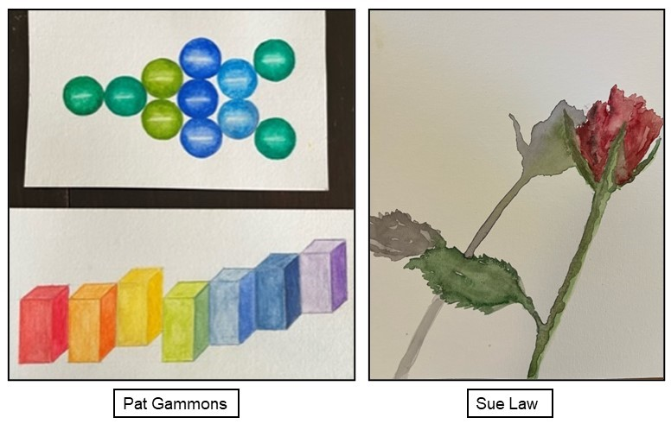

Photography for Fun (Stan Darling): Meets on the 3rd Monday of the month at 2.30 pm for a 2-hour session in Holme Pierrepont & Gamston Village Hall. We meet next on Mon 15 May when the topic will be ‘Moods’. Last month, the subject was ‘Ceilings’ which resulted in many high and mighty photos but below are two modest demonstrations of lateral thinking.

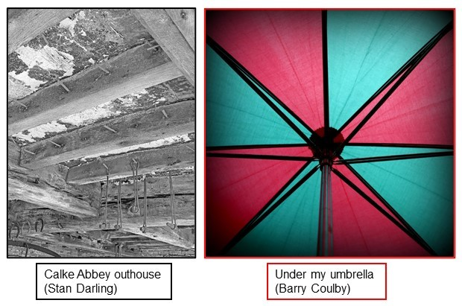

Psychology (Isabel Martindale): Meets on the 3rd Tuesday of each month at 2.00 pm in The Meadow Covert pub. We meet next on Tues 16 May. A group member selects a topic to introduce prior to discussion and sends out content information beforehand. Space in the group is limited due to the venue arrangements.

Quiz Night (George & Sheila Golledge): Occurs on the 3rd Monday of selected months with a maximum limit of 30 members. The next quiz will be on Mon 15 May at 7.00 pm in the Meadow Covert pub.

Science Group (John Todd): Meets at 2.00 pm on the 3rd Wednesday of the month in Holme Pierrepont & Gamston Village Hall. A charge of £2 per member covers the cost of hiring the hall and speaker expenses. On Wed 17 May, John will provide ‘A simple introduction to the atom’ (“It has to be simple, otherwise I will not understand what I am talking about.”). On Wed 21 June, Andrew Przeslak will give a talk on ‘Bird Biology’.

Scrabble (Sue Brittain): We meet on the 3rd Monday of the month at 2.00 pm at a member’s home on a rotational basis. We meet next on Mon 15 May. This is friendly, social group and the main aim is simply to enjoy ourselves. We do not keep records of winners or losers and there is no league. New members are always welcome.

Shakespeare Play Reading Group (Josephine Cutts): Meets on the 4th Thursday of the month at 2.00 pm at Jo’s home. On Thurs 25 May, we will finish reading parts from ‘Richard II’ before moving on to ‘Henry IV’.

Spanish Group (Janet Fishel): We are now meeting on the 1st and 3rd Wednesday of the month at 11.00 am in the Meadow Covert. We are moving on to Unit 13 of Pasos 1 and will learn about parts of the body, illness, accident and emergency. We will also learn the Perfect Tense, which enables us to explain what has happened, either to ourselves or to others. We meet next on Wed 3 and 17 May. Due to venue constraints, the group size is limited.

Sunday Singles (Barry Coulby & Marie Smith): This social group was set up by Cherry Brandon 4 years ago and has been a great success. Thank you, Cherry, for all your work. Unfortunately, other commitments mean that Cherry is stepping down as group leader. However, Barry Coulby and Marie Smith have volunteered to take over the reins as joint leaders. The group meets on the 4th Sunday of the month at 12.00 noon in the Willow Tree pub. Our next meeting will be on Sun 28 May. New members are welcome to join.

Table Tennis (Isabel Martindale): We meet each Wednesday at 10.50 am in the foyer of Rushcliffe Arena and play until noon when we visit the cafe. The next meeting is on Wed 3 May. We have lots of laughs, enjoyable exercise and are improving our playing skills.

Walking Group (Sheila & George Golledge): Meets on the 3rd Friday of each month. We meet next at 10.30 am on Fri 19 May.

Wine Tasting Group (Richard Davis): Meets at 2.00 pm on the 4th Wednesday of the month in Holme Pierrepont & Gamston Village Hall, Old Tollerton Road, Gamston NG2 6NX. On Wed 24 May, we will return to our review of Noble grapes, tasting a variety of Tempranillo wines with guidance from Richard. Our emphasis remains ‘Live, Laugh and Learn’ without getting too serious.

Writing for Fun (Pauline Barrett): We meet at 10.15 am on the 1st Thursday of the month at the home of a group member and, for this reason, the group size is limited. We meet next on Thurs 4 May and will continue the topic ‘Earth, Wind, Water or Fire’.

Writing with a Purpose (Andrew Newsum-Smith): We are a new group of budding writers (or better) looking to welcome new members. We plan to meet at 2.00 pm on the 3rd Thursday of the month at the home of a group member. We meet next on Thurs 18 May in Edwalton village where we will share ideas on “why didn’t I do that?”.

Share Your Family Memories of WW2

The University of Oxford is organising a nationwide campaign called “Their Finest Hour” with Lottery funding. It aims to collect and preserve the stories and objects of WW2. As well as artefacts from the front, there are the experiences of those at home. You can subscribe to a national email group at https://forms.office.com/e/ctt2eu6v2c to share views and air questions. You can also go online to upload your war-related stories and materials at https://theirfinesthour.english.ox.ac.uk/

Did You Know?

The u3a National Newsletter: You can sign-up for this national newsletter by going to u3a.org.uk/newsletter. It is sent monthly by email to members with news, events and offers from across the u3a movement. Members can also send in stories and other items.

Legal Helpline: Members can access a 24-hour Legal Helpline by phoning 0344 770 1040 and quoting u3a Legal Helpline.

Community Save a Life Scheme: This is a FREE online training scheme designed to teach basic life-saving skills. If interested, visit www.virtual-college.co.uk/prepared.

Suzy Lamplugh Trust: This exists to ensure that everyone feels and is safer through Campaigning, Training and the National Stalking Helpline. It provides advice on Internet safety, particularly when using social networks, online dating sites, computers, email and mobile phones. For information, visit www.suzylamplugh.org.

EGDu3a and the Wider Community
Trent Dementia. A Nottingham-based charity which aims to improve the quality of care, support and wellbeing of people living with dementia. It runs projects and events for them and their supporters. If someone you know has had a recent dementia diagnosis, you can contact them via www.trentdementia.org.uk or on 0115 748 4220.

Saving Plastic Bottle tops. Plastic bottle/jar tops can be dropped off at the Tollerton Post Office on Melton Road. All proceeds go to the Dove Cottage Hospice in the Vale of Belvoir.

Grantham Canal. The Canal and River Trust encourages Rushcliffe residents to take advantage of the haven for wildlife presented by the Grantham Canal. The charity also runs regular volunteering sessions in order to tackle litter, lay hedges, etc. To find out more, visit canalrivertrust.org.uk.

Bulk Waste Collection. If you have items that your local Waste & Recycling Centre cannot accept, there are other possibilities. For large items, call 0115 981 9911 or book collections via the rushcliffe.gov.uk website. For large electrical items, call 0115 914 8408.

Recycle your old Spectacles. If you have an old or unwanted pair of spectacles, you can help others with sight-related issues living locally and in developing countries by simply handing them in to the Specsavers store at 25-27 Central Avenue, West Bridgford.

Litter Picking. A group meets regularly at Holme Pierrepont & Gamston Village Hall on the 3rd Saturday of each month to pick up local litter. Equipment is provided by Rushcliffe
Council. Register to join and get details via gamstonlitterpickers@gmail.com.

Bob Hope Quotes (from Patricia Gammons)

ON GOLF: "Golf is my profession. Show business is just to pay the green fees."

ON RECEIVING THE CONGRESSIONAL GOLD MEDAL: "I feel very humble, but I think I have the strength of character to fight it."

ON HIS FAMILY'S EARLY POVERTY: "Four of us slept in the one bed. When it got cold, mother threw on another brother."

ON HIS SIX BROTHERS: "That's how I learned to dance. Waiting for the bathroom."

ON HIS EARLY FAILURES: "I would not have had anything to eat if it wasn't for the stuff the audience threw at me."

“Following in Mother’s Footsteps…” (Terry Mayhew)

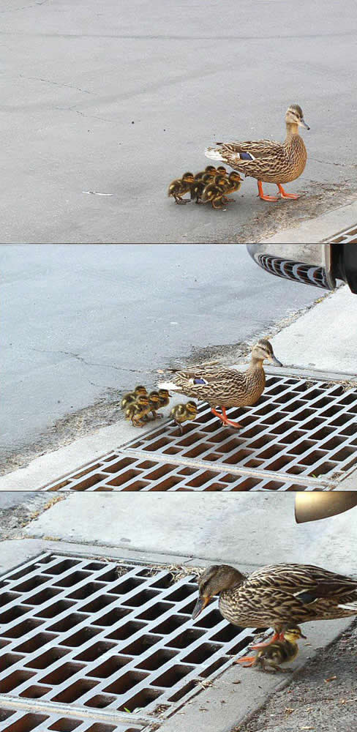

Joke from Joan Mayhew

A man is struggling down the road, trying to move a wardrobe. An elderly neighbour stops and enquires “Why don’t you ask a friend to help you?”. The man replies “I have. He’s inside carrying the clothes.”.

Diary Summary of This Month’s Events and Interest Groups
Week/  Time | Monday  1,8,15,22,29 | Tuesday  2,9,16,23,30 | Wednesday  3,10,17,24,31 | Thursday  4,11,18,25 | Friday  5,12,19,26
1st am | 1st Craft Group (no meeting due to Bank Holiday) |  | 3rd Church Visiting Group  3rd French (ad hoc)  3rd Table Tennis  3rd Spanish | 4th Writing for Fun
1st pm |  | 2nd Bridge |  | 4th Gardening
2nd am |  |  | 10th Table Tennis  10th History Group  10th Art Appreciation (NB change of date)
2nd pm |  | 9th Bridge  9th Book Club |  | 11th Monthly Meeting at Edwalton Church Hall
3rd am | 15th Craft Project Group |  | 17th French  17th Table Tennis  17th Spanish | 18th Painting Group  18th Lunch Club (Poppy and Pint) | 19th Walking Group
3rd pm | 15th Scrabble  15th Photography for Fun  15th Boardgames (NB date change)  15th Quiz Night | 16th Bridge  16th Psychology | 17th Science | 18th Writing with a Purpose
4th am |  |  | 24th Table Tennis | 25th Chatterbox Group
4th pm |  | 23rd Bridge | 24th Wine Tasting | 25th Shakespeare Play Reading
NB: Sunday Singles Group will meet this month on Sun 28 May
NB: Cycling Group will meet on the 1st and 4th Monday or Friday.

