Edwalton, Gamston & District u3a (EGDu3a)
Interim Newsletter No 12, April 2021
Web Version
Executive Committee Members for 2020/21

Although we have a full committee to manage our u3a until the proper AGM, we have urgent need of a volunteer for the post of Treasurer (see Message below).

Position | Name | Contact
Chair | George Golledge | gosh.golledge@ntlworld.com
Vice Chair Elect | Isabel Martindale | martindaleic38@gmail.com
Treasurer | Mike Brandt | mikebrandt100@gmail.com
Business Secretary | Susan Bryant | sueandgarrybryant@gmail.com
Membership Secretary | Carol Shuttleworth | cys@theshuttleworths.co.uk
Groups Coordinator | John Todd | johnh.todd@yahoo.co.uk
Outings Coordinator | Joan Mayhew | joanmayhew@hotmail.com
Webmaster | Steve Barrett | sbaru3a220@yahoo.com
Newsletter Editor | Terry Mayhew | terry.mayhew@nottingham.ac.uk
Speaker Seeker | Josephine Cutts | etndil@icloud.com
Minute Taker | Sheila Golledge | gosh.golledge@ntlworld.com
Minute Taker Elect | Susan Bryant | sueandgarrybryant@gmail.com
Refreshments | Sue Ambler | sue.ambler@icloud.com
Poster Distributor | Martin Ambler | martin.ambler@btinternet.com
Past Chair | Chris Shaw | chrisshaw20038@hotmail.com

Message from our Chair (George Golledge)

It is very important for our u3a that we fill the post of Treasurer. This role is not only key to our Executive Committee but our u3a will not be able to continue if this position is not filled by the time of the next AGM. WE NEED A VOLUNTEER FOR THE POST. Here is a brief description of what is required:

Skills
Good communication skills are required with a knowledge of Word and Excel
Tasks
• to manage the bank account including receiving membership subscriptions and payment of expenses
• to prepare a summary of income and expenditure for committee meetings
• to prepare an income and expenditure account for external audit prior to the AGM
• in conjunction with the Executive Committee to agree on the level of annual subscriptions
• to provide guidance to group leaders on the maintenance of financial records and levels of petty cash funds
• to attend monthly speaker meetings and Executive Committee meetings
• submission of accounts to the Charities Commission is currently not required
• a company car is not provided with this position!

Help is available for any volunteer. If interested, please contact me in the first instance at EMAIL REDACTED.
Virtual Multidisciplinary Group (Josephine Cutts)

The Virtual Multidisciplinary Group is an all-inclusive group which was set up to keep us going through lockdown. With the possibility that we will be able to return to our normal activities in the near future, the current project is likely to be the last one. Hopefully, it will be as good and well received as the others have been, both in our own u3a and also regionally and even nationally. This is a great credit to all who have contributed to them.

We are now in the process of putting together the seventh portfolio of work, the subject being ‘Constructions’ and there is still time to contribute to it. The subject can encompass a wide range of building activities, including those made by man or beast, from large scale edifices to humble garden supports. We look forward to seeing your ideas.

Contributions should be sent to EMAIL REDACTED by Wed 14 April. You may submit more than one contribution, but please restrict each individual contribution to no more than 2 PowerPoint slides. Please consult earlier projects to see what that could contain in terms of text and images. If a single contribution exceeds this limit, then we will have to edit text and/or images ourselves.

Note about Zoom Sessions

Zoom sessions have come to play an important role in allowing some of our u3a activities to continue and for members of various Interest Groups to at least see and chat with each other. However, it is important to note that these sessions, particularly those involving talks from invited speakers (such as those organised by Jo Cutts and John Todd, see below) entail certain restrictions. Therefore, we ask you to comply as follows:

- In a single talk/lecture or series of talks/lectures, any virtual live event is a one-time event using copyrighted materials. You may only view the talk/lecture at the scheduled date and time at which it is staged.
- No recording of the session(s) for future viewing by attendees or for attendees missing part or all of the session is permitted.
- No attendee is permitted to take screenshots, download or record any part of any event on any device including smartphone, laptop, tablet or camcorder. Links to Zoom talks/lectures will be emailed to members by either the u3a organiser or the invited speaker. Do not share this link with anyone else.

Zoom Speakers (Josephine Cutts)

Our virtual meeting this month is on Thurs 8 April and continues the medical theme which John Todd so ably started with his talk about the NHS in March. This time, we are going to hear from Gareth Howell who is one of the History advisers for BBC Radio Notts. He will tell us about ‘Medieval Medicine’ including superstition and science.

You will be sent the Zoom link for the meeting by email a few days beforehand. Just click on the link and follow the instructions.

In May, we have Mike Hill of Nottinghamshire Search and Rescue.

News from Interest Groups

Groups Co-ordinator (John Todd): We are now entering the period of easing restrictions on our personal activities. It may be possible, for some groups, to start meeting outdoors, depending on the weather. After 8th July, we can consider meeting indoors. I know that many of us (including me) are very hesitant about such meeting. Any decision about restarting groups rests with the group leader and their members and I am happy to provide a listening ear, advice and guidance. Talking to Group Co-ordinators in other u3as in Nottinghamshire, we all wondering how best to return to some degree of normality.
As you know, we have a Zoom license that enables us to hold meetings lasting longer than the 40 minutes usually applied to "free" use. We make use of this license for speakers at the monthly Main meetings as well as Science Group and Committee meetings, but it is available to be used by any group. Just contact me (EMAIL REDACTED) and I will send further details.

Interim Zoom Social Group: Pauline Barrett coordinates a group meeting fortnightly on Zoom on Thursdays at 10.30 am. The format is basically a virtual ‘tea/coffee and chat’. Please contact Pauline at EMAIL REDACTED for details.

Craft Group (Prue Brandt): We continue to meet on Zoom every second week and enjoy our chats and the opportunity to catch up on all our news. Members are continuing their own projects and some are knitting blankets and cardigans for a charity in Syria. We now plan to knit, sew or crochet Christmas stockings to be filled with chocolates for children in families who have suffered domestic abuse.

French Group (Terry Mayhew): We have not met since lockdown and are unlikely to do so under existing restrictions. Social media (Zoom, Teams, etc) are not really suitable alternatives to face-to-face contact and, in any event, would exclude members who do not have computer access. After over 3 years, I am stepping down as group leader. When we can meet again face-to-face (and without masks!), the group will be in the very capable hands of Eileen Loftus (EMAIL REDACTED).

Gardening (Fiona Steele): Hi fellow gardeners, I am sorry not to have been in touch lately but do hope everyone is enjoying the definite signs of Spring that are all around us, in the garden and countryside. I hope it won't be long until we can meet up for a coffee and chat, in smallish groups, in gardens perhaps? Until then, Good Luck with any seed sowing that may be going on! Best wishes (EMAIL REDACTED).
History Group (Patricia Gammons): We are a large group not all of whom have Zoom. I continue to send out communications to group members. A number of them have researched a subject and contributed to the Virtual Multidisciplinary Group presentations organised by Jo Cutts. They are doing so for the coming topic. We look forward to meeting up again, but we are a large group to be meeting indoors safely. We will see how things go as we are eased back into a more normal way of life.

Outings Group (Joan Mayhew): No Outings will be arranged for 2021 until Lockdown ends, monthly meetings resume (for sign-up) and social distancing is relaxed. Money already paid for Papplewick Pumping Station or the National Brewery Museum will be retained for a future visit, hopefully in 2021. There is a list of those who have paid. If you cannot make the next arranged visit, you will be refunded but please note that the National Brewery Museum has been paid a non-refundable deposit, so members who are not able to go next time would get £6 refund which represents half of the £12 paid.

Photography for Fun (Stan Darling): In March, the group illustrated the theme ‘Out of Winter into Spring’ as best we could. To be fair, we all found it rather difficult to get ideas without Spring flowers and without the occasional Lamb. However, two examples of submissions are given below. In April, members will have a wider range of options capturing ‘Metal’.
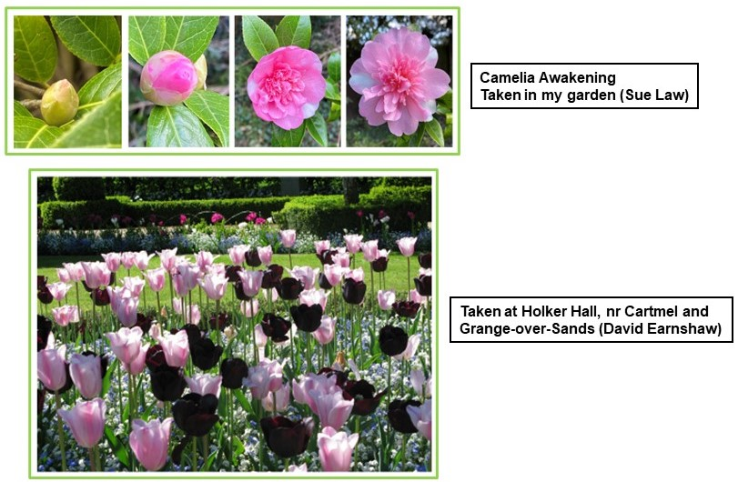

Science Group (John Todd): A very interesting talk in March from Andrew Przeslak about the application of the principles of relativity in the design of radiotherapy linear accelerators. On Wed 21 Apr at 2.00 pm, Professor Jim Turner will tell us “What we owe to Einstein”, with no maths. Albert Einstein contributed far more than his theory of relativity and our current knowledge about the structure of matter, gravity and the universe can be traced back to him. If you are not a member of the Science Group but would like to join us, even for one meeting, contact me and I will send the Zoom link to you (EMAIL REDACTED).

Shakespeare Play-Reading & Painting Groups (Josephine Cutts): The Shakespeare Group is not meeting at present but Shakespearean quotations continue to appear in the Virtual Multidisciplinary Group projects. Members have been asked to find appropriate quotations for the next topic ‘Constructions’. Members of the Painting Group, which is also not meeting physically, have contributed regularly also to the Multidisciplnary topics with their usual enthusiasm and are all set to apply their skills to ‘Constructions’.

Sunday Singles (Cherry Brandon): We were just becoming established, initially as a social dining group, when along came all the prohibitions about socialising and dining, so we ground to a halt. As soon as restaurants open and Sunday lunches become possible again, we look forward to re-launching. In the meantime, hopefully, members are all well and managing to cope with what has been, to say the least, a very challenging time.

Wine Tasting Group (Richard Davis): There is a possibility that our monthly meetings may resume in July. This is assuming that we emerge from lockdown in line with current Government expectations. I will be contacting members in the coming weeks to canvas their opinions regarding resuming indoor meetings.

Writing for Fun Group (Pauline Barrett): We have been meeting via Zoom since last April and have enjoyed sharing contributions on a variety of topics including ‘The Destination’ and ‘I had just sat down for my morning cup of coffee when…’.

To Poets, Painters and Others

The King Lear Arts Club was set up for entrants to the King Lear Prizes (the national arts competition for older people stuck at home because of Coronavirus) but is now open to anyone over 60. It might be of interest to u3a members of the Painting and Writing for Fun groups, amongst others.

Every Friday, members of the King Lear Arts Club receive an email with creative writing and art challenges in their email inbox. Membership is free. Members of the club send in their works by email and the Club then shares the best entries with everyone in the next week’s email. To join the Club, go to https://www.kinglearprizes.org.uk/artsclub

Plastic Tops and Milk Bottle Tops

If you have any plastic bottle tops that you have been collecting for Pauline Barrett, then please note that these can be dropped off at the Tollerton Post Office on Melton Road. All proceeds go to the Dove Cottage Hospice in the Vale of Belvoir.

u3a Learning Programme

The Third Age Trust has designed and advertised a varied programme of initiatives to support u3a members through the winter months. All initiatives are available at: https://www.u3a.org.uk/learning/national-programmes. It is intended to release them on a staggered basis. Events which require u3a members to book a place can be found at: https://www.u3a.org.uk/events/educational-events. The website will be updated regularly so keep checking these pages.

Local Information for Rushcliffe (Terry Mayhew)

Grantham Canal. The Canal and River Trust is encouraging Rushcliffe residents to take advantage of the haven for wildlife presented by the Grantham Canal. The charity also runs regular volunteering sessions in order to tackle litter, lay hedges, etc. To find out more, visit canalrivertrust.org.uk

Bulk Waste Collection. If you have waste items that your local Waste & Recycling Centre cannot accept, here are some other possibilities. Mattresses, furniture and other large items can be collected by calling 0115 981 9911. Online bookings can be made via the rushcliffe.gov.uk website. For large electrical items, call 0115 914 8408.

Royal National Institute for Deaf People (RNID)

The following message to our u3a has been received from Henry Skinner, the Regional Information Manager for the RNID.

“We are a charity to make life fully inclusive for deaf people and those with hearing loss or tinnitus. With the Covid-19 restrictions in place, access is challenging for those who are deaf, hearing impaired or suffering from tinnitus. An electronic copy of an information pack pack on managing hearing loss and tinnitus during Covid-19 is available. If you are interested, please send me an email and I will send you a copy. The email address for contact is information.midlands@rnid.org.uk”

The Great Escape: Part I (Stan Darling)
The Great Escape Tunnel
Untouched for almost 7 decades, the tunnel used in the Great Escape has finally been unearthed. The 111 yd passage, nicknamed 'Harry' by Allied prisoners, was sealed by the Germans after the audacious break-out from the POW camp Stalag Luft III in western Poland. Despite huge interest in the subject, encouraged by the film starring Steve McQueen, the tunnel was undisturbed over the decades because it was behind the Iron Curtain and the Soviets had no interest in its significance.
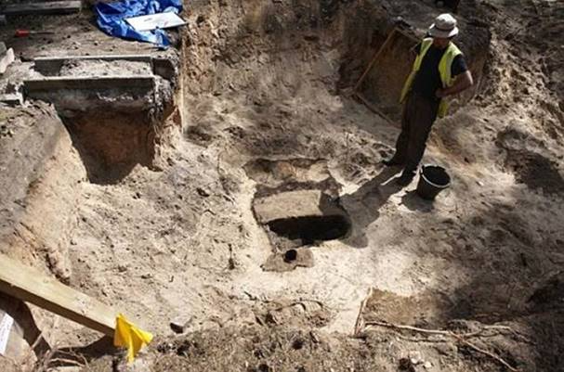
But, at last, British archaeologists have excavated it and discovered its remarkable secrets. Many of the bed boards which had been joined to stop it from collapsing were still in position. And the ventilation shaft, ingeniously crafted from used powdered milk containers known as Klim Tins, remained in working order. Scattered throughout the tunnel, which is 30 feet below ground, were bits of old metal buckets, hammers and crowbars which were used to hollow out the route.
Some 600 prisoners worked on 3 tunnels at the same time. They were nicknamed Tom, Dick, and Harry, and were just 2 feet square for most of their length. It was on the night of March 24 and 25, 1944, that 76 Allied airmen escaped through Harry. About a third of the 200 prisoners, many in fake German uniforms and civilian outfits and carrying false ID papers, who were meant to slip away, managed to leave before the alarm was raised when escapee number 77 was spotted.
Only 3 made it back to Britain. Another 50 were executed by firing squad on the orders of Adolf Hitler, who was furious after learning of the breach of security. In all, 90 boards from bunk beds, 62 tables, 34 chairs, and 76 benches, as well as thousands of items including knives, spoons, forks, towels and blankets, were squirreled away by Allied prisoners to aid the escape plan under the noses of their captors.
NO Americans were involved in the operation. Most were Brits and Canadians (all the tunnelers were Canadian personnel with backgrounds in mining), others were from Poland, New Zealand, Australia, and South Africa.
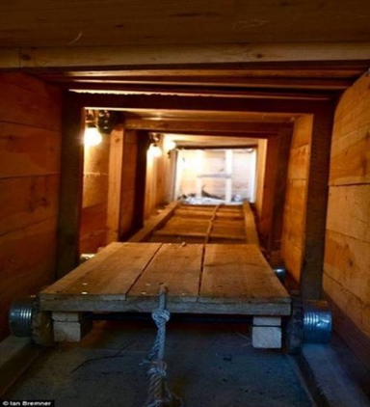 Tunnel reconstruction showing the trolley system.
The latest dig, over 3 weeks in August, located the entrance to Harry, which was originally concealed under a stove in Hut 104. The team also found another tunnel, called George, whose exact position had not been charted. It was never used as the 2,000 prisoners were forced to march to other camps as the Red Army approached in January 1945.
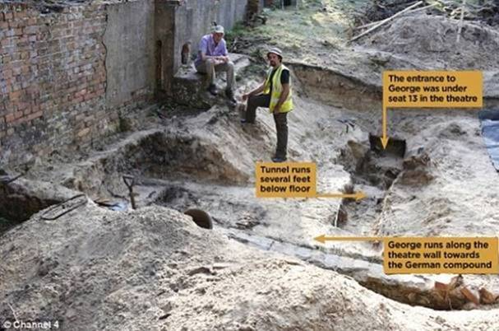
Watching the excavation was Gordie King, 91, an RAF radio operator, who was 140th in line to use Harry and, therefore, missed out. “This brings back such bitter-sweet memories.” he said as he wiped away tears. “I'm amazed by what they've found.”
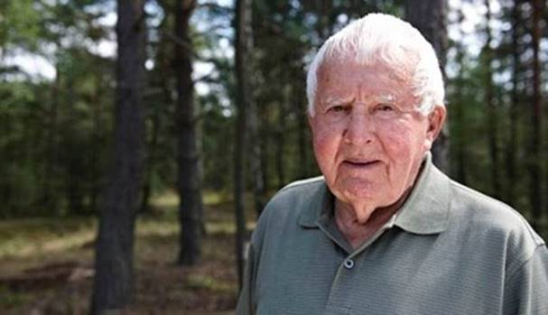 Gordie King, 91, on his return to Stalag Luft III.

Roadmap out of Lockdown (Terry Mayhew)

Information on the gradual easing of National Lockdown restrictions can be found on the government website: https://www.gov.co.uk/coronavirus.

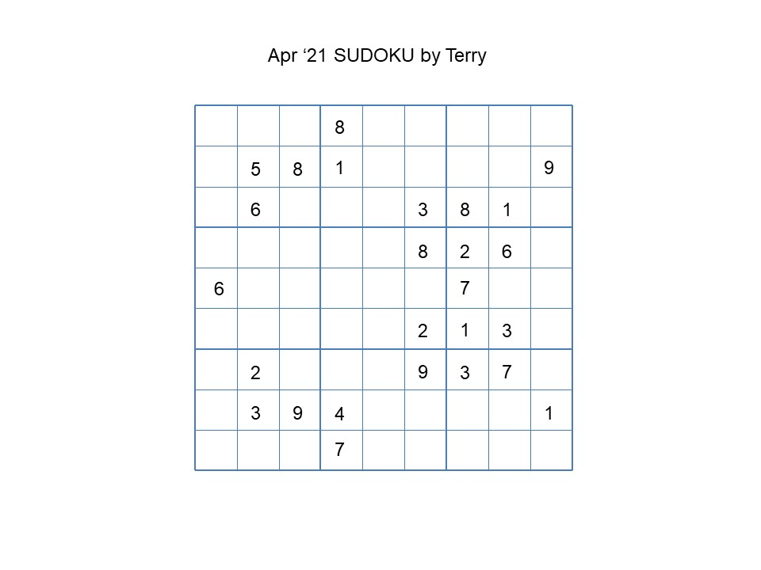

Answers to March Quiz 12 (Joan Mayhew)
1. Covid-19, the coronavirus disease first seen in 2019; 2. SARS, severe acute respiratory syndrome; 3. SAGE, Scientific Advisory Group for Emergencies; 4. PPE, personal protective equipment; 5. CDC, Center for Disease Control (USA); 6. ICU, intensive care unit; 7. mRNA, messenger ribonucleic acid; 8. ONS, Office for National Statistics; 9. COBRA, Cabinet Office Briefing Room A; 10. MERS, middle eastern respiratory syndrome.
April Quiz 13 (Joan Mayhew)

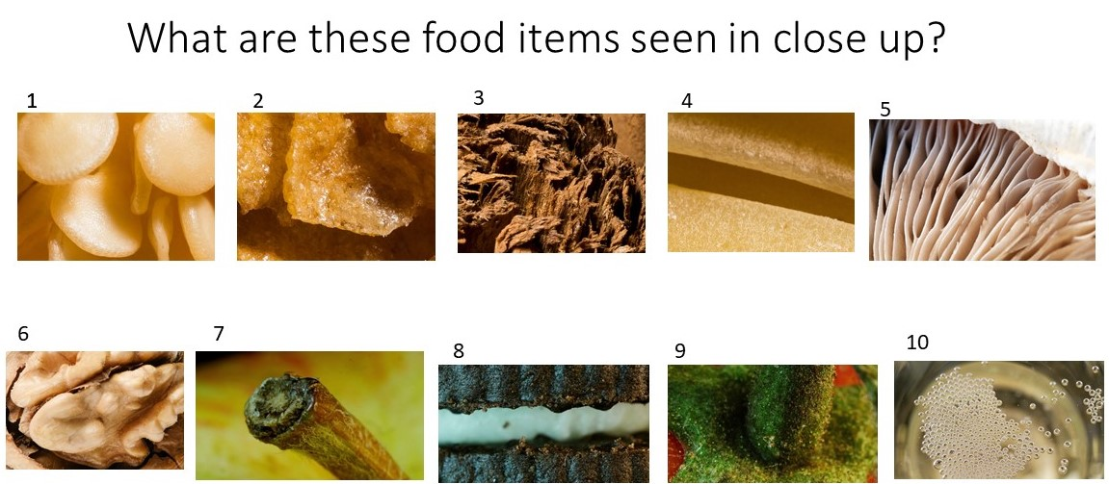

Joke Images (Anon & Marilyn Sands)


