 | Edwalton Gamston & District U3A  Newsletter June 2015
AGM
 Strawberry Tea
11th June
1.45 for 2.00 at the Gamston Community Hall (nr Morrisons)

Please bring your membership card
AGM

[Grab your reader’s attention with a great quote from the document or use this space to emphasize a key point. To place this text box anywhere on the page, just drag it.]

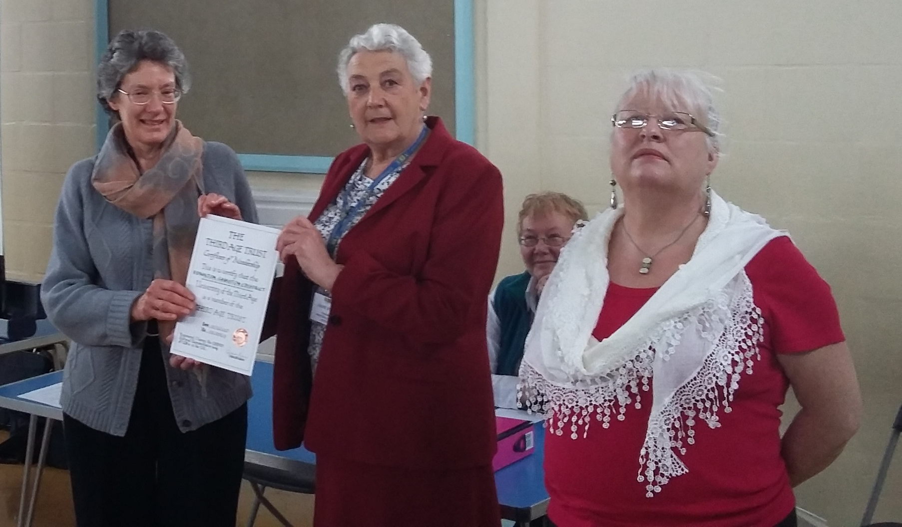
Jean, our outgoing Chairman, presented with the Certificate of Membership to the U3A by Jane and Karen from the Trust.

Our next meeting will be our first AGM at the Gamston Community Hall (nr Morrisons) is on 11th June, doors open at 1.45 for 2 pm prompt start. Please bring your membership card along. If you have not renewed your membership there will be a chance to do so.

Please note we can take cash or cheque but cannot accept card payments (Morrisons has a cash machine). You can deduct £3.50 affiliation fee if you are in another U3A (please bring their card) and £2 per household if not taking the Third Age Matters U3A magazine. Please ask our treasurer for details.

AGM

As this is our AGM, there will be no £1 on entry but donations to the £58 hire of the hall would be appreciated. The notice circulated to all members in early May detailed the business to be dealt with. Copies of the Agenda and the Accounts will be available at the meeting.

Committee Nominations – Our Chairman, Jean Hudson
By the deadline 9 nominations for Executive Committee Members and Officers had been received (none duplicated), so there will be no elections. The nominees are: Steve Barrett (Webmaster); Michael Brandt; Richard Davies (Treasurer); George Golledge; Michael Groves; Ann Hatch; Bill Kelly (Vice Chair); Peter Knott; Chris Shaw (Chairman). There are still 3 vacancies on the Committee including the Officer role of Secretary. Subject to agreement by members present at the AGM, I shall invite further volunteers/nominations to the Committee from the floor. Please reconsider if this is something you can do to help your U3A move forward – this is an opportunity to work with others, have fun and influence how our U3A develops. The more people on the committee, the more thinly the workload is spread and it can be fun!

Speaker
Our Speaker, immediately following the AGM business meeting, will be Karen Middleton, the Family Worker at West Bridgford Methodist Church, who will talk about “Church in Community” covering the many community support activities offered in the area.

Dates for your diary and local items

On 9th July our Speaker will be Tracey Francis, Head of Community Support at Nottinghamshire County Cricket Club, who will talk about Notts CCC outreach work in the community through the Trent Bridge Community Trust.

Due to holiday season, there will be no main meeting in August. There will be an informal get together with tea and coffee at 2 pm in the Meadow Covert.

The West Bridgford Methodist Church hosts a concert by the Sinfonia Chorale on Saturday 13th June at 7.30. Tickets from Grices on the Avenue.

Looking for something to keep you active? We have had a request for volunteers from one of the local charity shops in West Bridgford. Good for the brain – and socialising too!

Your Interest Groups and Events

Group Leaders We still need potential group leaders. It is not rocket science and duties should be shared by members of the groups.

If you want to start a group contact one of the committee, below or at the meeting. Do you have any ideas, especially if it is one you want to happen and in which you are going to be actively involved?

Summer Schools The U3A runs a yearly summer school, this year in Shropshire (w/c June 13th) and Cirencester (w/c August 20th). Topics include Creative and Biographical Writing, Film and Theatre, Garden Design, Drama, History, Science, Music and Singing, Shakespeare, Literature, Language and Country. Details from Chris Shaw chrisshaw20038@hotmail.com .

New Members There will be a regular coffee morning at 11 am at the Meadow Covert on the 3rd Thursday of the month (the week after the main meeting), where you can find out more about the U3A and its activities/groups. Open to new and seasoned members alike.

Social Lunch Group The first quarterly lunch meeting is to take place on Tuesday, 9th June at the West End Restaurant on Central Avenue, West Bridgford, who currently offer a midweek carvery lunch for £7.75 (3 courses – or £6.50 for main course only).
Please contact Nadine on 0790 467 0058 to let her know numbers by noon on 2nd June.

************************************************************************************************

Bridge Group The Bridge Group meets every Tuesday afternoon at 2.15pm. It is generally held at the home of Jeremy and Josephine Cutts at Village Street, Edwalton. We are progressing well but would welcome newcomers. If you can play Bridge and would like to join us for the occasional game that would be fine too. Please contact me – Ann Widdowson annwid62@gmail.com

Craft Group The Craft Group meets on the first Monday of each month from 10-12. This month we are meeting at the home of Sue Harding at 66 Dunster Rd, West Bridgford. We are going to share the results of our projects undertaken in the last six months. New members are always welcome. Please contact Prue Brandt on 01159234383 or on pruebrandt@hotmail.com.

Creative Writing A meeting is to be set up at a later date, depending on demand. If anyone is interested in joining the Creative Writing/Writers’ Group please contact the Group Leader, Pauline Barrett on 0115 937 4817 or paulinebarrett@hotmail.co.uk.

French This is an intermediate level conversation group. We meet once a month on the third Wednesday morning in the Meadow Covert pub for a French chat. If you would like to join please contact Cherry Brandon at c.brandon2@ntlworld.com.

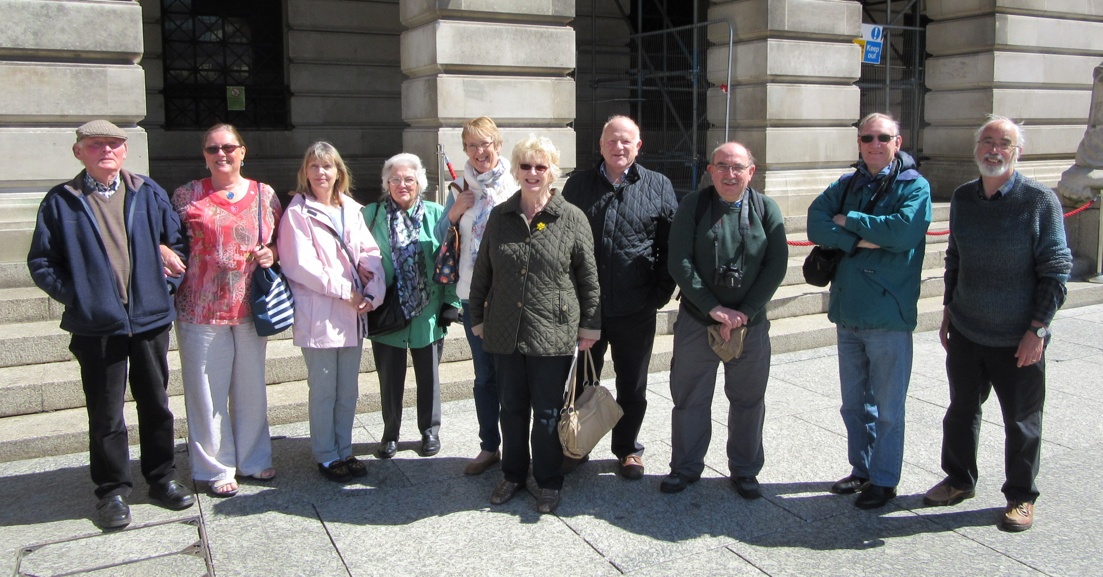
History Group At the end of April the History Group paid a visit to the Nottingham Council House. It was a most interesting afternoon especially as we had been looking at the development of the Market Square over the centuries.

We were shown around by an excellent guide, who showed us the many artefacts given by benefactors of the City, and ended up sitting in the Council Chamber!

We are planning to visit Leicester in July to visit the Richard 111 Exhibition and a trip to Historic Newark in the near future.

IT Group Due to a change in personal circumstances Steve Barrett is now no longer able to be the leader of this group. Therefore until an alternative leader is found, the start of the group will be further delayed. Could you help? If so contact stevebar555@yahoo.co.uk

Outings group There is a rolling programme of outings as below:-

- July (date to be arranged) – Bridgemere Garden Centre (claims to be the biggest in the UK with 6 acres of display gardens. Entry free but coach cost. Full day.
- August – Pub Quiz at 7 pm Monday 24th Meadow Covet + meal £6. We need about 30 people for the pub to give us our own area.
- September (date to be arranged) – Chatsworth House and Sotherby's Art in the grounds. Coach cost + entry.
- September – Thursday 24th 5.30 – 7.45 BBC Evening Tour. Free. Fully subscribed but there may be another in the new year.
- October – Thursday 15th . All day. National Civil War Museum, Newark. Car share or bus to reduce cost. £5.40 for groups of 10+ and age 65 or over.

Please keep checking outings group table at the main meeting. Contact Joan Mayhew at joanmayhew@hotmail.com, or 0115 945 5156 to join or for information.

Please note due to the AGM the book stall will take place next meeting (July).

Photography The U3A is running a competition for 2015 entitled Britain’s Wildlife, with a closing date of 31st August. Prizes include a year’s subscription to Amateur Photographer and gift tokens. Details from Chris Shaw chrisshaw20038@hotmail.com .

We are meeting regularly on the third Monday of every month at 2pm, usually at members’ homes. We are all levels of ability, knowledge and equipment. We discuss different ways of improving our artistic and technical skills, use of equipment, subjects and the processing of images, all very relaxed, usually over a cup of tea or coffee.

We would welcome more members to join our group. If you have an interest in photography you would be very welcome to join us, please contact Peter Allsopp either by telephone on 0115 921 5008 or by email at plaU3A@gmail.com.

Poetry With apologies – Peter is unable to lead the meeting scheduled for Tuesday 16th June due to a knee operation. Contact Peter Knott peaknutt@btinternet.com. 0115 981 0749. New members very welcome.

Short and Medium Walks Walks in June will be as follows:-

Medium distance 16th June. Bunny to Wysall circular, details to follow. Leader, George Golledge. Contact gosh-golledge@ntlworld.com.

Short distance 24th June. Meet Gamston Community Hall 10.30am, Canal side / Holme Pierrepont. Contact Nadine – 07904 670058.

Contact Jean Hudson egdu3awalks@gmail.com or 0115 9231032.

Spanish This is a twice monthly group. Meetings are normally on the second and fourth Tuesday morning from 11.00 to 12.30 in the Meadow Covert. Please contact Janet Fishel on janetfishel@yahoo.com.

Wine Tasting Group The Wine group has had 3 very enjoyable meetings. We have just put together our programme for the coming months. We will be tasting/reviewing wines from the regions of France.

Our next meeting will be on Wednesday 24th June when we will be tasting wines from Alsace and learning about the region, its people and history. We currently have a keen following of around 10 regular tasters. New members would be very welcome. Contact Richard Davis on 0115 981 2970 or richarddavis970@btinternet.com.

EGDU3A Website http://edgamu3a.weebley.com
Information on:-
- When and where our main monthly meetings are and who our speakers are,
- How to join and information about the interest groups.

Our Webmaster, Steve would particularly welcome comments, ideas, photos and group updates. Please contact him either on stevebar555@yahoo.co.uk or edgamweb@yahoo.com.

Steering Committee Members – general contact number 07581400419
Peter Allsopp Member plaU3A@gmail.com
Steve Barrett Webmaster stevebar555@yahoo.co.uk
Beverley Clare Member bevclare.bc@gmail.com
Richard Davis Treasurer richarddavis970@btinternet.com
Bill Kelly Publicity & Newsletter william.kelly60@ntlworld.com
Peter Knott Speaker Seeker peaknutt@btinternet.com
Ann Hatch Group Co-ordinator hatchann@hotmail.com
Jean Hudson Chairman jeanhudsonjss@aol.com
Paul Hudson Membership Secretary phudson8@aol.com
Chris Shaw Secretary secretary1egdu3a@outlook.com

Travel information – Buses to Morrisons stop – no:s 5 or 7 or the L shopper buses.
If you know someone without transport, could you give them a lift there or back?

Do you have anything for the newsletter? Please mail the editor (Bill) by 26th June.
You can find information about us on the U3A website www.nottsu3anetwork.org
Our own dedicated website is http://edgamu3a.weebly.com/
If you are interested in shaping your future U3A, call/text 0758 140 0419
or contact us by the secretary at secretary1egdu3a@outlook.com
Subscriptions for 2015/6 please to our membership secretary
Paul Hudson on phudson8@aol.com or at the meeting.

Group Meetings Leader Telephone Email
Art Appreciation 3rd Wednesday 2:30 Roy Townsend 0115 923 5080 roy.townsend@btinternet.com
Book Club 2nd Tuesday 2:30 Roy Townsend 0115 923 5080 roy.townsend@btinternet.com
Bridge Every Tuesday 2:15 Ann Widdowson 0115 945 5025 annwid62@gmail.com

Crafts 1st Monday 10-12am Pru Brandt 0115 923 4383 pruebrandt@hotmail.com
Creative Writing Please contact leader Pauline Barrett 0115 937 4817 paulinebarrett@hotmail.co.uk
French 3rd Wednesday Cherry Brandon c.brandon2@ntlworld.com

History 2nd & 4th Monday 2:00 Paul Hudson 0115 923 1032 phudson8@aol.com
Meet at Meadow Covert Looking at Local History (a) West Bridgford, Edwalton & Gamston
(b) Nottingham & suburbs
Looking at World War Histories (especially effects on Notts & localities)

Music Appreciation 2nd Wed of month John Todd 0115 914 7074 johnh.todd@yahoo.co.uk
Photography 3rd Monday 2:00 Peter Allsopp 0115 921 5008 plaU3A@gmail.com
Poetry Peter Knott 0115 981 0749 peaknutt@btinternet.com

Scrabble 3rd Tuesday 2:00 Sue Brittain 0115 937 4751 suebrittain@hotmail.co.uk
Spanish 2nd & 4th Tuesday am Janet Fishel janetfishel@yahoo.com
Stamp Collecting John Todd 0115 914 7074 johnh.todd@yahoo.co.uk
Wine Tasting 4th Wednesday Richard Davis 0115 981 2970 richarddavis970@btinternet.com

Walking Jean Hudson 0115 923 1032 egdu3awalks@gmail.com

Medium (4-7 miles) normally 3rd Tuesday 10 am details above or advised
Short (2-3 miles) 4th Wednesday 10.30 am details above or advised

Leaders are still wanted for Archaeology, Art Practical, Discussion, Gardening and Yoga.

For venue details and to join a group please contact the Leader

